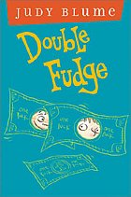
Book Report by Courtney C
Title: Double Fudge
Author: Judy Blume
Illustrator: Peter Reynolds
Main Characters: Fudge, Pete, Tootsie, Mum, Cousin Howie and Richie

Best Part of the Story:
Chapter 8 Cousin Coincidence
Fudge’s Dad meets his long lost cousin Howie in a gift shop and Fudge finds out that he’s not the only Fudge and he meets Fauna and Flora.
You find more information about the Fudge books at http://judyblume.com/books/fudge.php

