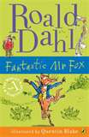
Book Report by Tahlia A
Title: Fantastic Mr Fox
Author: Roald Dahl
Illustrator: Quentin Blake
Main Characters: Mr Fox, Mrs Fox, The small foxes, Badger, Boggis, Bean and Bunce

Best Part of the Story:
When they start to dig and dig and Mr Fox finds a passage which is full of food. Mr Fox sneaks back down the passage and gets enough food and drink for a party while Mrs Fox sets up the party!
You find more information about Roald Dahl and his books at http://www.roalddahl.com/

