Book Report by Kari
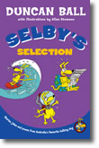
Title: Selby’s Selection

Author: Duncan Ball
Illustrator: Allan Stomann
Main Characters: Selby, Mrs Trifle and Dr Trifle

Best Part of the Story:
When Selby tells you about himself – it’s like a diary. Also I like the start when Selby writes a letter to you (Selby is the same age as me!!!).
You find more information about Selby and Duncan Ball’s books at http://www.duncanball.com.au/

